Name: Pranali Sonawane
Subject: MCSA
Date: 08-01-2026
Lab 22: VPN And Tree Domain

Server 1:
- Install Remote Access
- Tools Routing & remote access Server 1(local) config select custom config VPN Access Finish.
- Run ncpa.cpl Ethernet 1 Add Preferred DNS give 1.1.1.1
- Active Directory Users and Computer
- create vpnuser give Properties Click on Dial-in select Network access Permission (Allow Access)
- Administrator give Properties Click on Dial-in select Network access Permission (Allow Access)

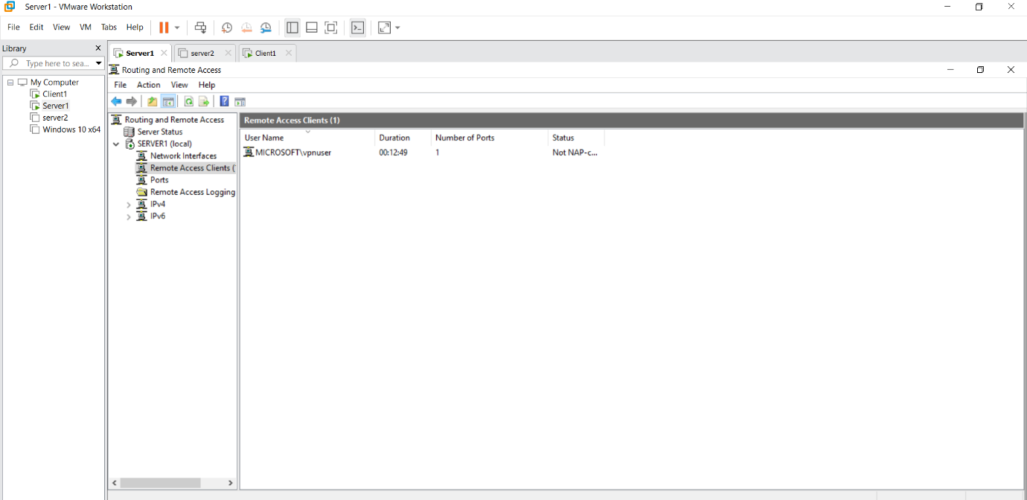
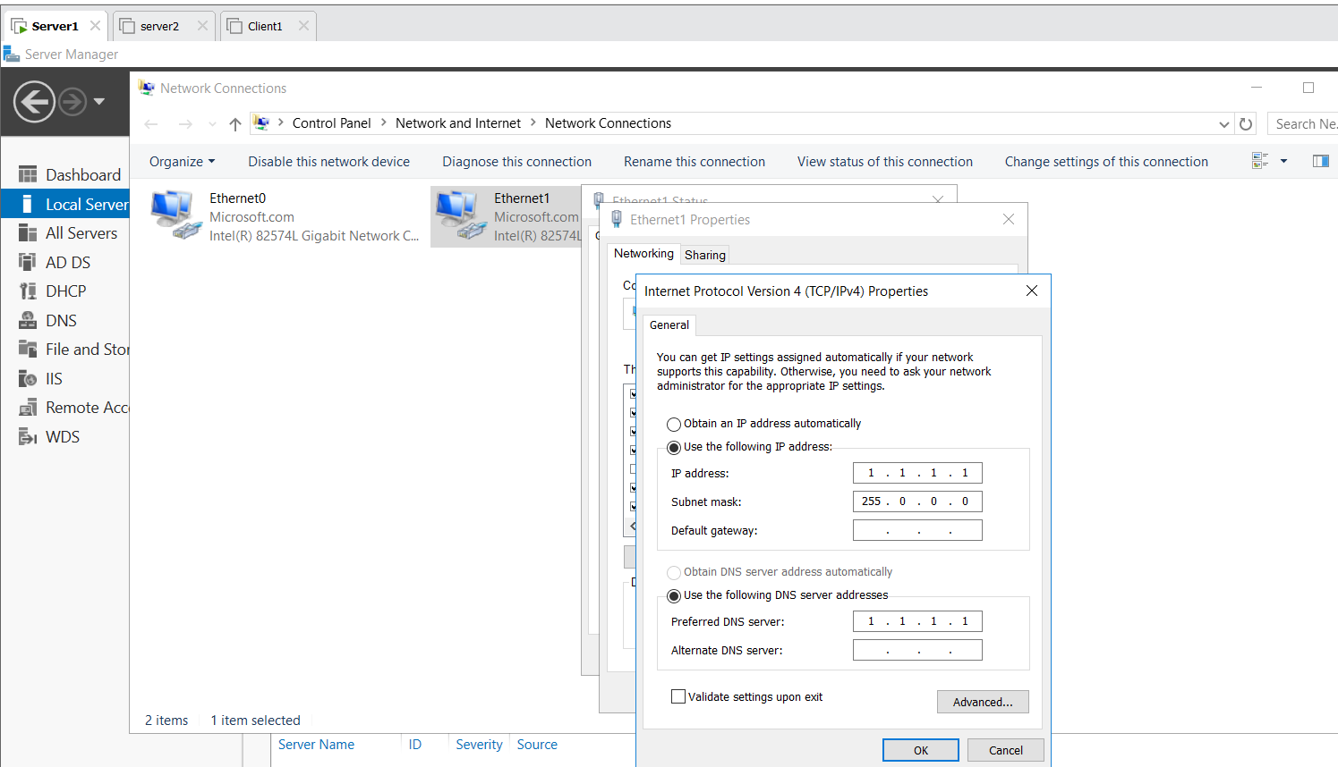
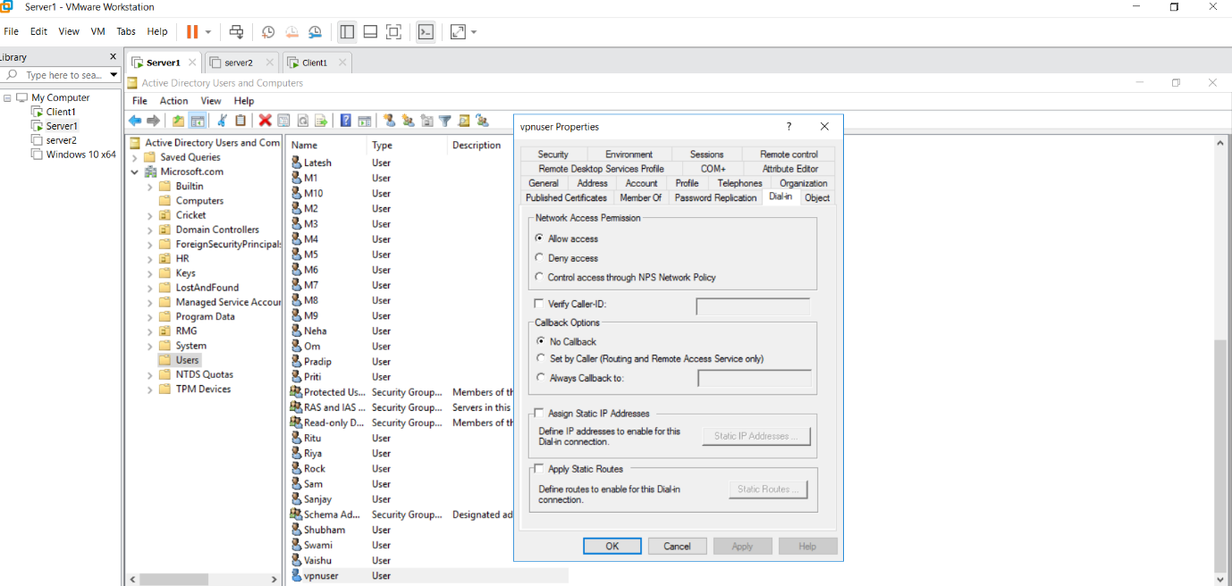
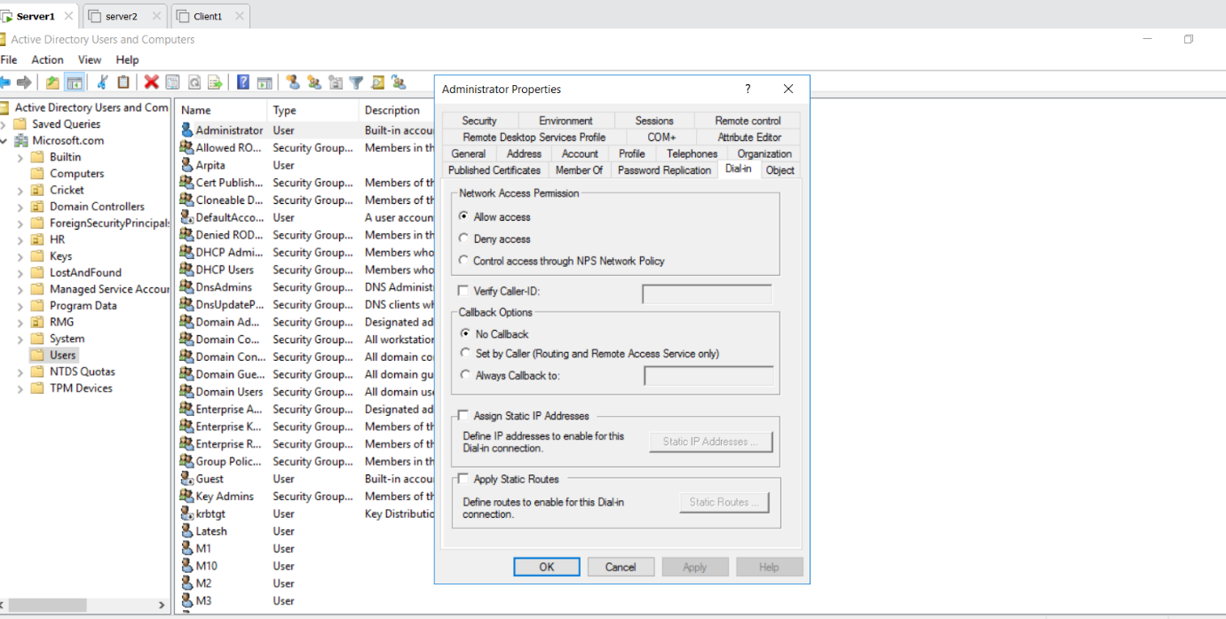
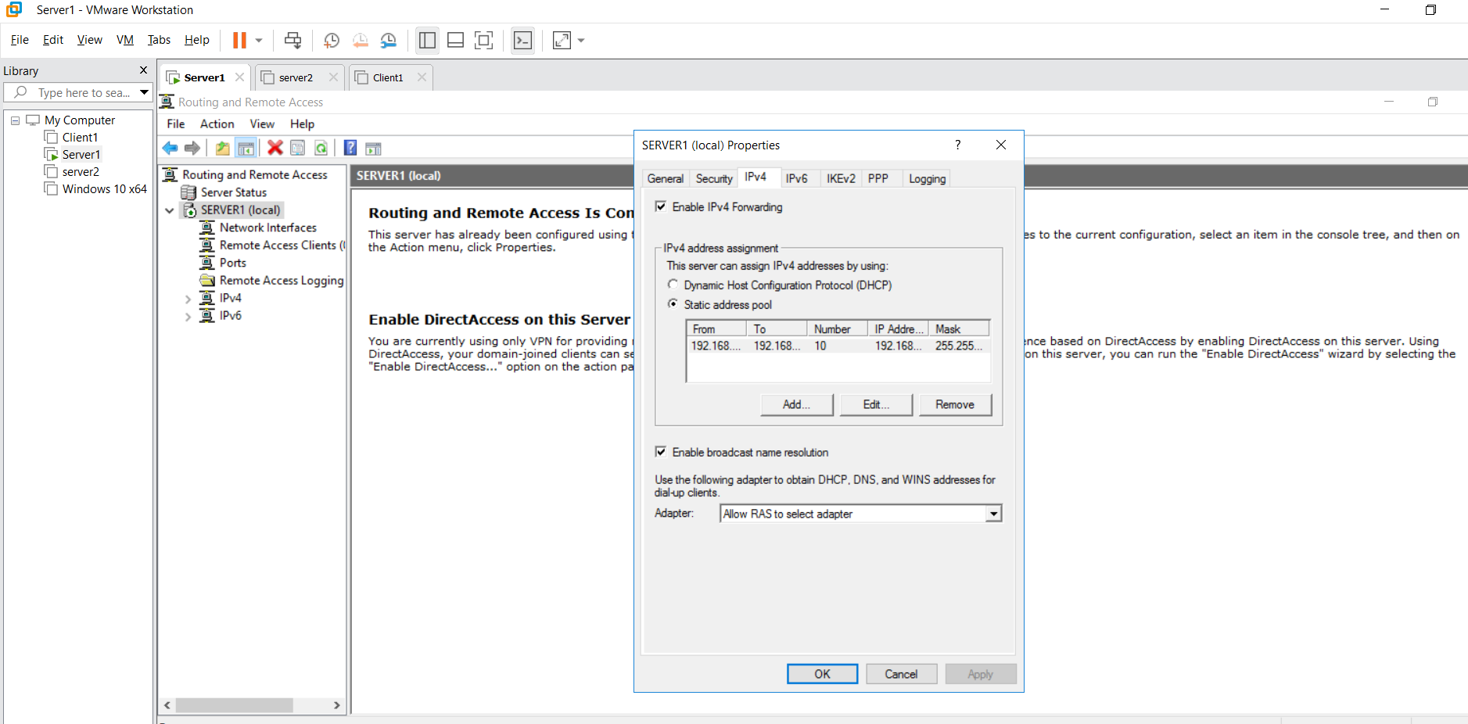
Client 1 :
Run ncpa.cpl Ethernet 0 Disable
Ethernet 1 Preferred DNS Give 1.1.1.2
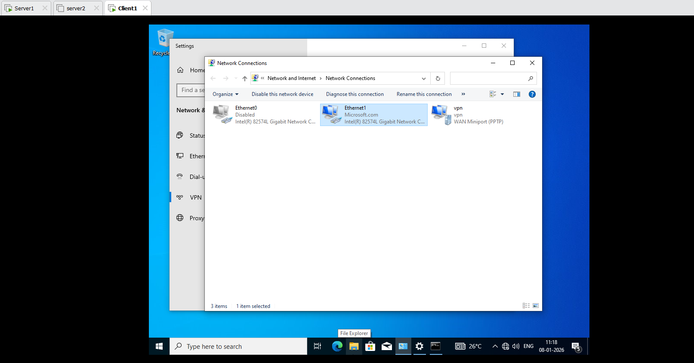

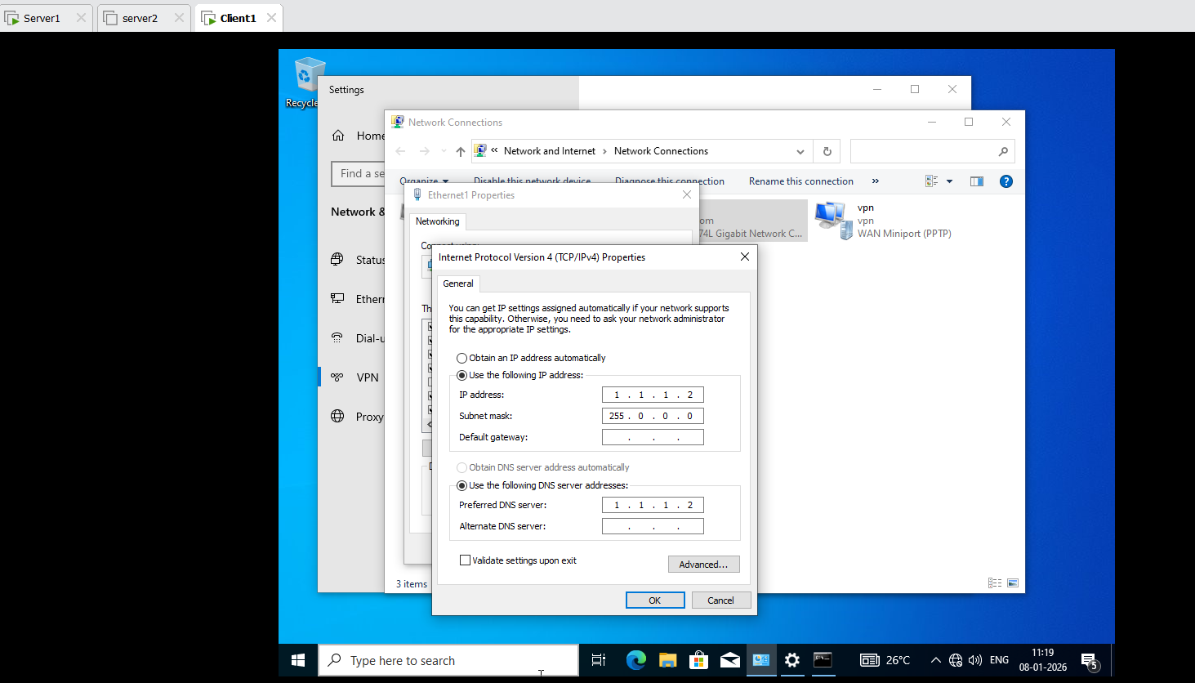
Client 1 :
Search Add a VPN Provider : Select Windows
Connection Name : vpn
Address : 1.1.1.1
Automatic
Give Username: vpnuser and Password: Password@123 Save

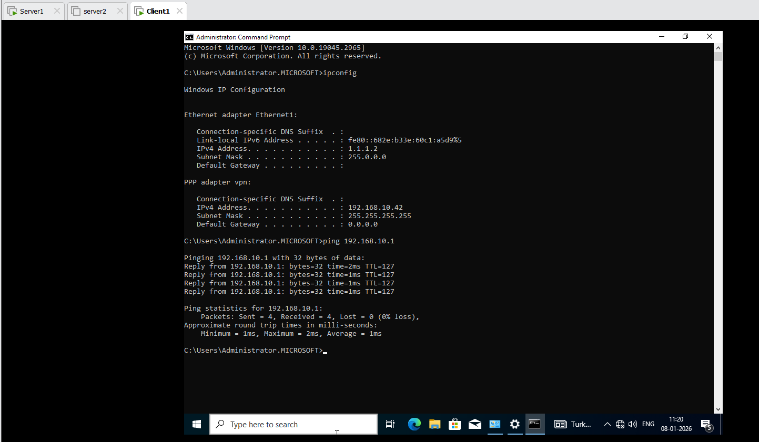

Tree Domain :
Server 2: Add Domain Cisco.com
- Add a Domain to Workgroup
- Install Active Directory Domain Service and DNS Server
- Promote
- Select Add a new Domain to an existing Forest
- Select Tree Domain
- Give Forest name : Microsoft.com
New Domain: cisco.com
- Change: Username : Microsoft\Administrator
Password@123
- Next
- Password Give
- Then NETBIOS : Cisco show
- Install
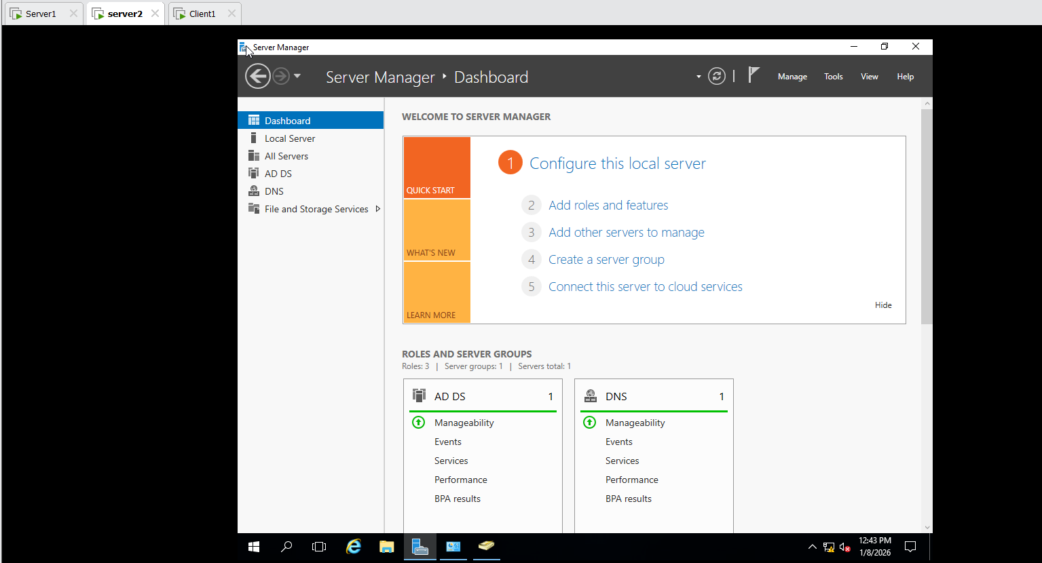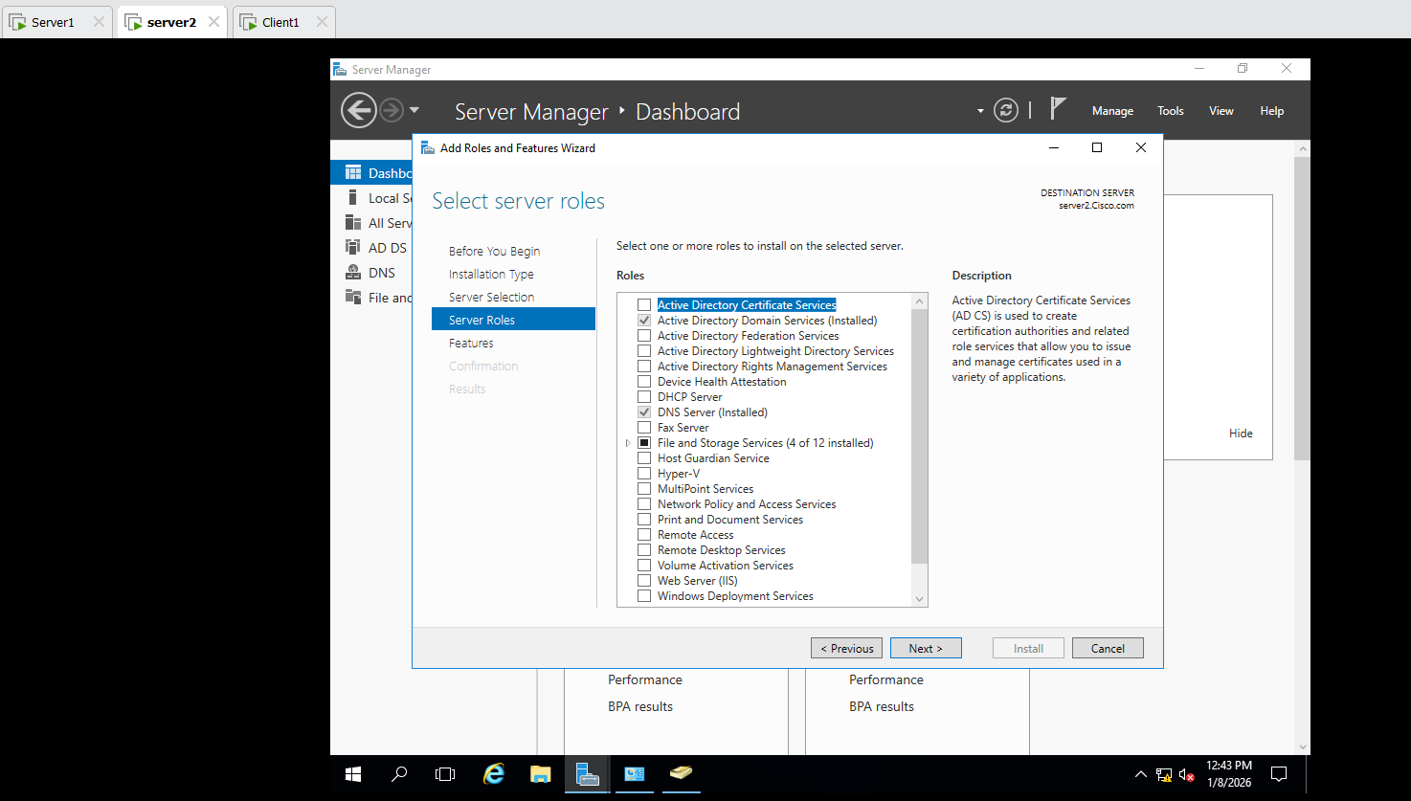
In Server 2 : Desktop
Cisco\Administrator is shown
Local Server Ethernet 0 Preferred DNS give ip 192.168.10.2
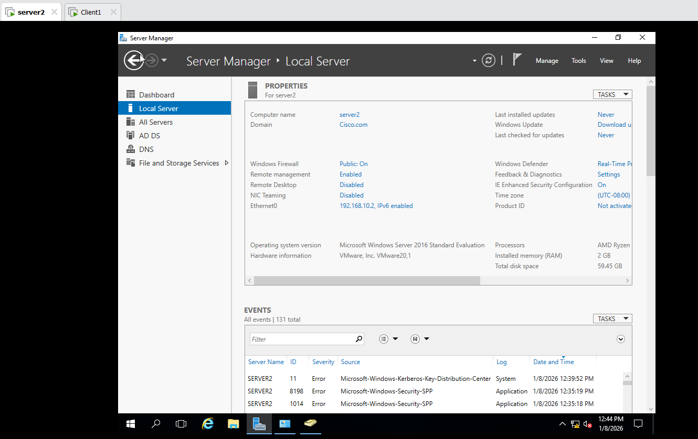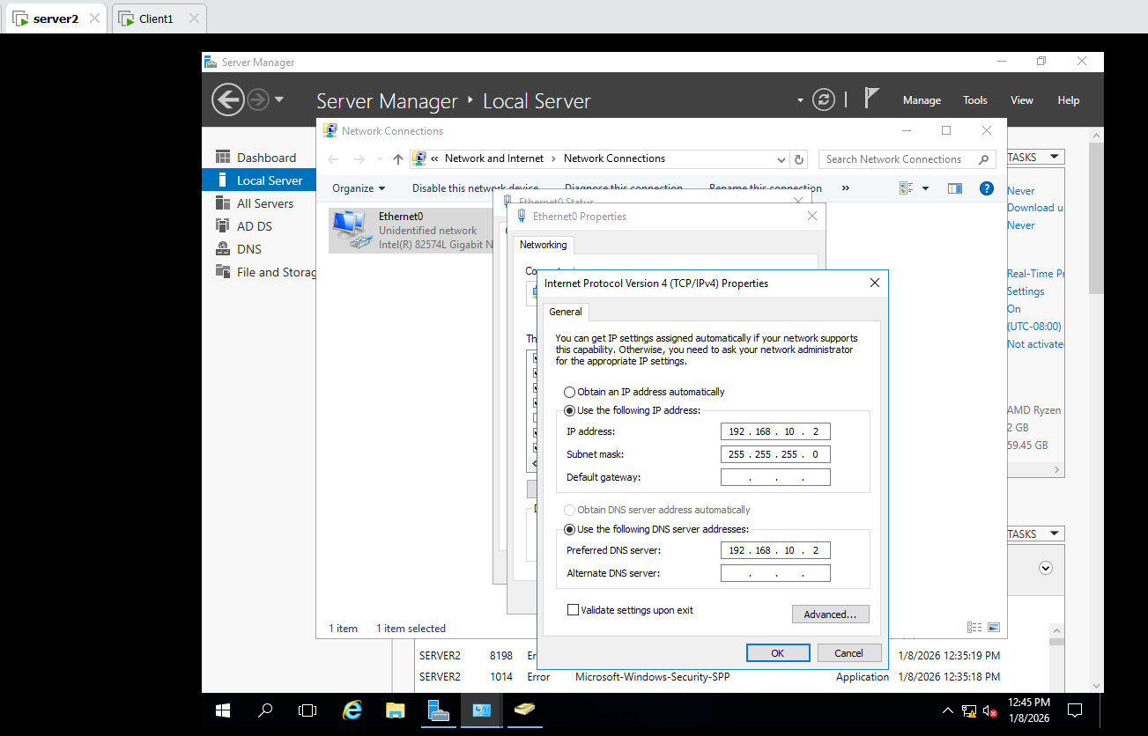
In Server 2 Active Directory Users and Computers Show Cisco.com
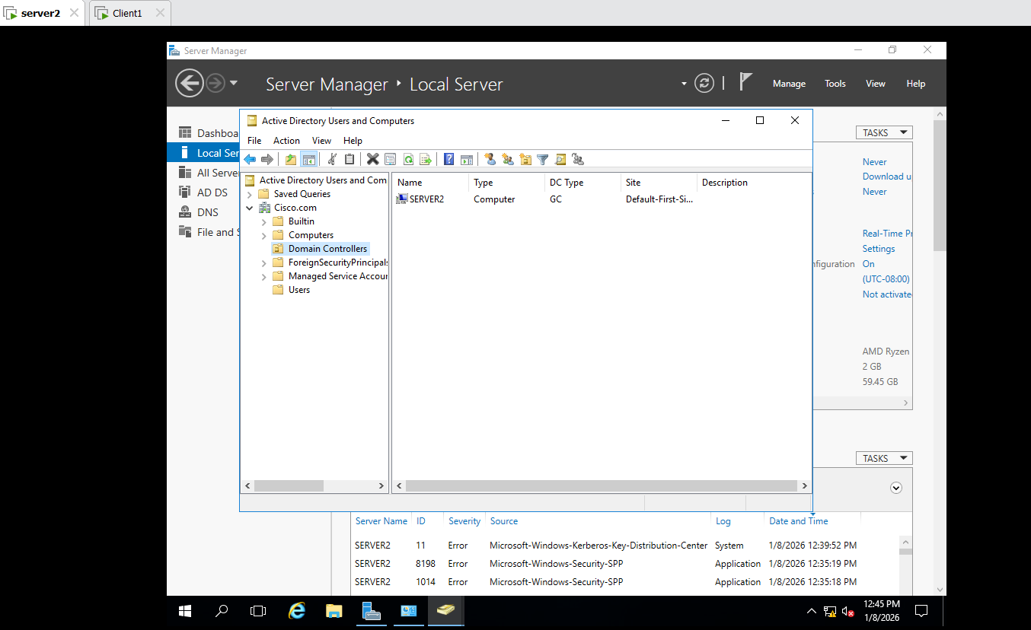
Problem is Face :
Server 1 :
Active Directory Users and Computers Computer Show Server2 then Delete it and Domain Controller in that Show Server 2 is then Delete it.

DNS
Forward Lookup Zone Microsoft.com Show Server 2 is Delete it.
Reverse Lookup Zone Show Server 2 then Delete it.
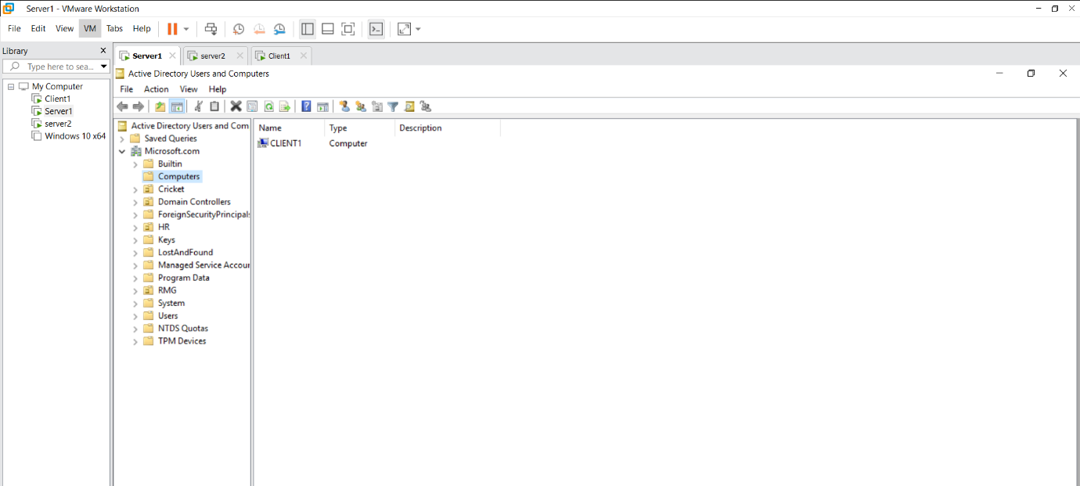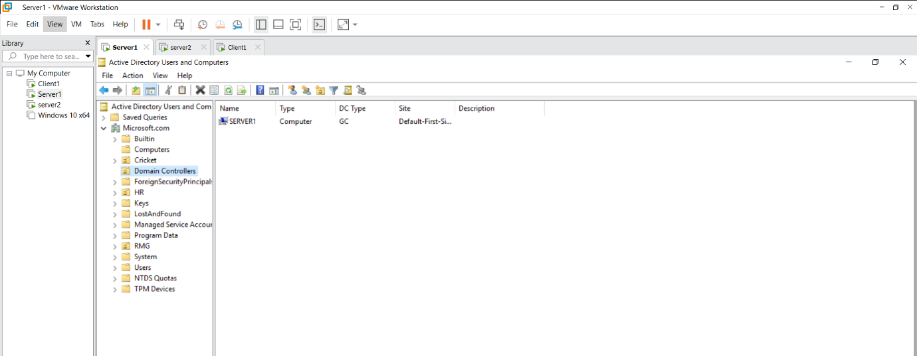
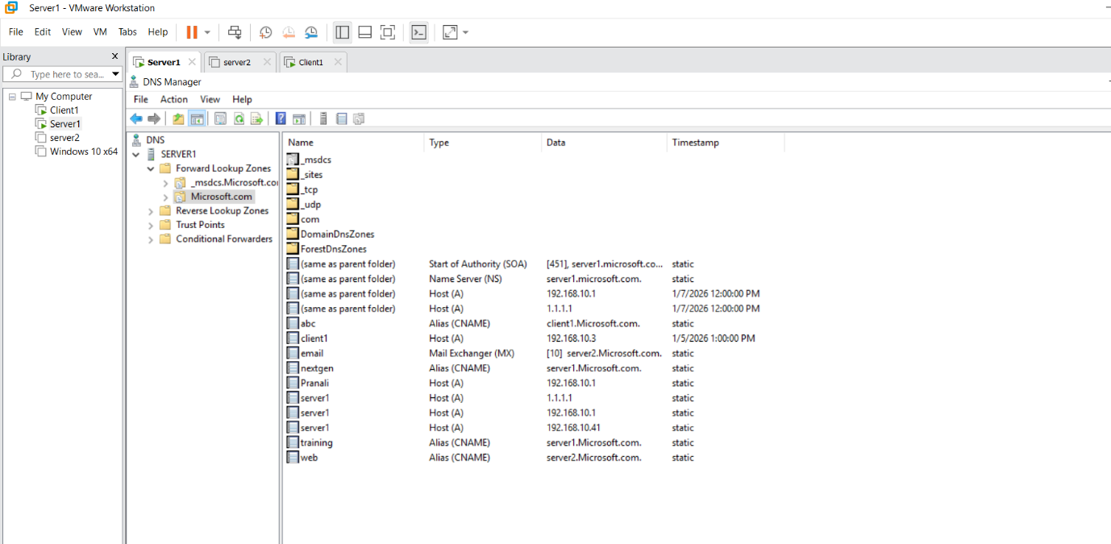
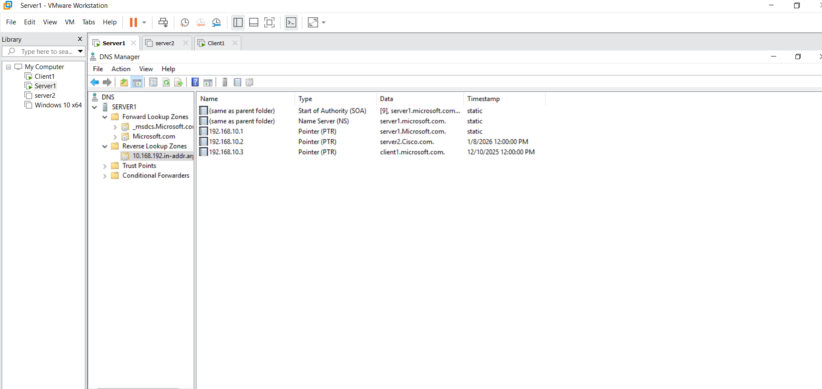
In Final :
Active Directory Users and Computers Cisco.com is Present.

